**Biological and Physiological Adaptations of Birds**

# Objectives

**Understand adaptations that make flight possible**

* Skeleton
* Musculature
* Respiratory System.
* Circulatory System.
* Digestive System.
* Reproduction.
* Senses
* Feathers

# Archaeopteryx **Fossil Record**

## Skeletal Adaptations

The sternum (breastbone), bears a prominent keel where the flight muscles attach. The furcula (wishbone), serves as a brace during the flight stroke Secondary feathers of the wing are supported by the forearm Wrist and hand bones are fused to provide firm support for the primary feathers.

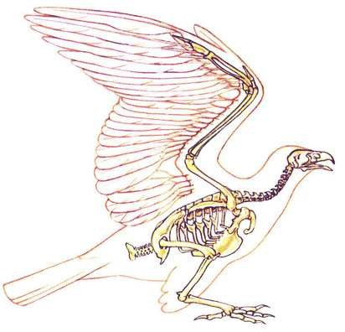

Sternum and Keel

Forearm

Fused Wrist and

Hand Bones

Primary

Feathers

Secondary

Feathers

Furcula

Pygostyle

Solid bones replaced with hollow bones thin internal struts for extra strength where necessary

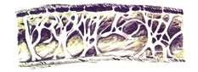

Bones of the skull are extremely thin Teeth replaced by a horny bill.

## Light but Powerful Musculature

Most birds have approximately 175 different muscles, mainly controlling the wings, skin, and legs The largest muscles control the wings and run between the upper arm and the keel The pectoralis major provides the powerful downstrokeThe supracoracoideus muscle raises the wing Uses a pulley-like system to lift the wing. These musclesconstitute about 20 – 25 percent of the bird's total body mass. 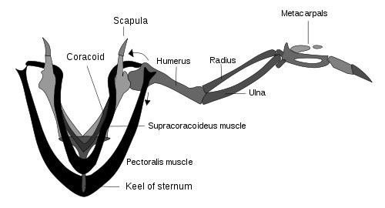

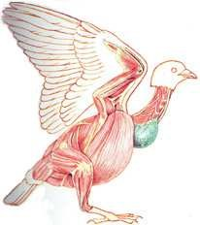

Pectoralismajor

Pulls the wing down

## Respiratory System

Due to the high metabolic rate required for flight, birds have a high oxygen demand Birds ventilate their lungs by means of air sacs.

These structures are unique to birds, and perhaps dinosaurs, too

Birds’ lungs obtain fresh air during both exhalation and inhalation

Birds lack a diaphragm.

The entire body cavity acts as a bellows to move air through the lungs

The active phase of respiration in birds is exhalation, requiring muscular contraction.Air flows through the air sac system and lungs.There is no mixing of oxygen-rich air and oxygenpoor, carbon dioxide-rich air as in mammalian lungs.

The partial pressure of oxygen in a bird's lungs is the same as the environment

Birds have more efficient gas-exchange of both oxygen and carbon dioxide than do mammals.

## Circulatory System

Birds, like mammals, have four-chambered hearts Makes possible a double circulation.Bird’s heart is large, powerful, and rapid in its beat

|  |  |  |
| --- | --- | --- |
| Animal | Heart as % of Body Weight | Heart Beats per Minute |
| Boa constrictor | 0.31 | 20 |
| Bullfrog | 0.32 | 22 |
| Man | 0.42 | 78 |
| Dog | 1.05 | 140 |
| Vulture | 2.07 | 301 |
| Crow | 0.95 | 345 |
| Sparrow | 1.68 | 460 |
| Hummingbird | 2.37 | 615 |

A bird’s digestive system can assimilate food at an extremely rapid rate

Most birds have digestive tracts adapted to their diet.

* Herbivores
* Carnivores
* 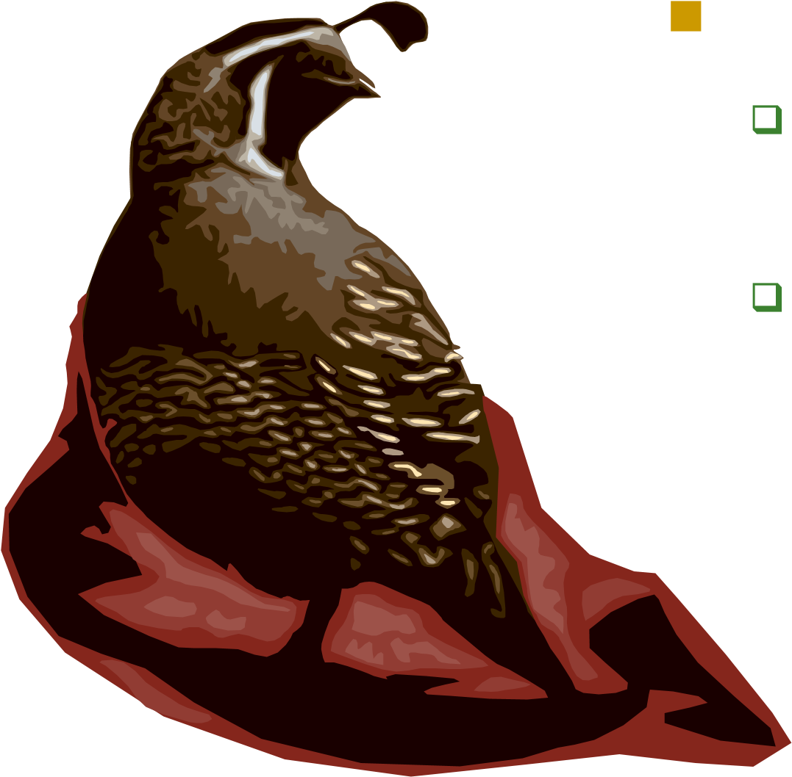Omnivores

## Herbivores

Feed on seeds, fruit, and other vegetable matter

Have a storage sac called the crop where food is macerated before it passes to the two-chambered stomach

Mixed with digestive juices in the first part

Ground into a pulp in the second part (the gizzard)

Herbivorous birds swallow small stones which assist the grinding of food in the gizzard.

## Carnivores

Feed on fish, animals, insects, and carrion. Do not usually have a crop If they do, it is small The gizzard is less muscular Functions as a normal Stomach.Some carnivores do not attempt to digest the bones and fur or skin of their prey Regurgitated in the form of a hard pellet.

The pancreas is slightly more well developed in birds than in mammals

Possibly as partial compensation for the lack of saliva and chewing

It produces enzymes for digesting carbohydrates, fats, and proteins.The liver has two distinct lobes each with its own duct leading into the small intestine Stores the bile.

In birds, the bile is acidic and not alkaline as it is in mammals.

## Excretory System

Another weight reducing adaptation in birds is the absence of A urinary bladder a urethra is The kidneys excrete nitrogenous wastes in the form of uric acid.

## Adaptations of the Reproductive System

Birds are the only class of vertebrates in which no species give birth to live young. Nearly all species possess only one ovary and oviduct They lay their eggs in the nest soon after the eggs are formed Reproductive structures atrophy during the non-breeding season.

## Vision

Birds have acute eyesight

Hawks are able to discriminate fine details at a much greater distance and much more quickly than humans. Hawks have a bony "brow" above the eye known as a *supraorbital ridge*. Raptors including owls have a "third eyelid" known as a *nictitating membrane* Eyes of a bird are relatively large.

## Hearing

As an adaptation for flight, birds lack an externally visible ear. The range of hearing in many species of birds is comparable with that of mankind Some birds have hearing that is much more sensitive than ours Owls not only are more sensitive to small sounds but they have asymmetrical ears Allows them to pinpoint the source of a sound extremely accurately.

## Smell

The olfactory lobes of most birds are very small, suggesting that they have a poor sense of smell. Some birds do use smell to locate food.

* Sea birds (Petrels, Shearwaters).
* Vultures.
* Kiwis.

## Feathers

Of all the organisms on earth, only birds have feathers.

* They are instrumental in flying.
* They play a critical role in temperature regulation.
* Their color patterns are essential in both display and camouflage.
* The mass of feathers on a bird’s body constitutes its plumage
* Feathers clump in distinct tracts with featherless areas in between
* Birds’ color patterns are built of these units Worn feathers are periodically replaced through a process called “molt”

**Barbs and Barbules**

## 

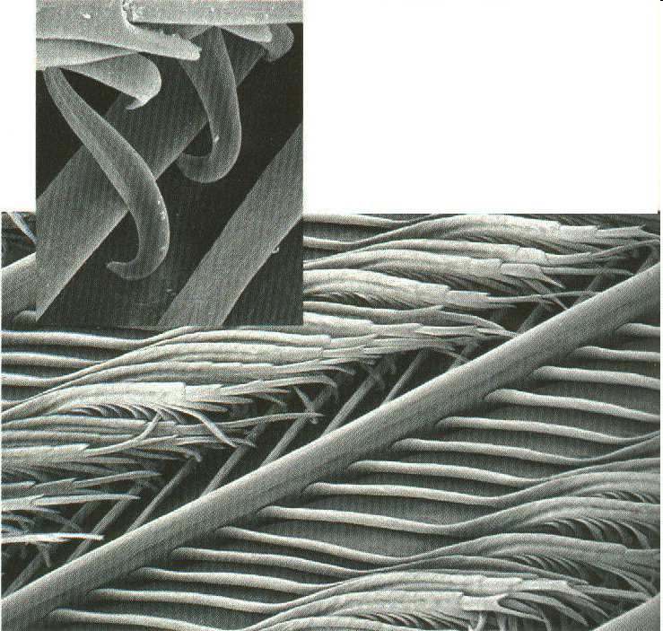

An electron microscope photograph

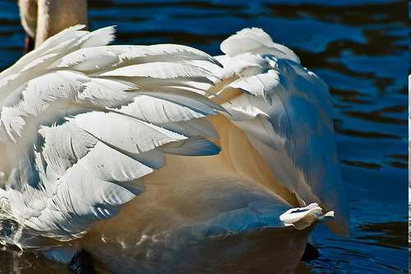

The number of feathers on a bird’s body varies

Around 1,000 on a hummingbird More than 25,000 on a swan.

## Feather Types

* Flight feathers
  + - Feathers of the tail (retrices)
* Long feathers of the wing(remiges)
  + - Primaries
    - Secondaries

Photo © Bob Fairley

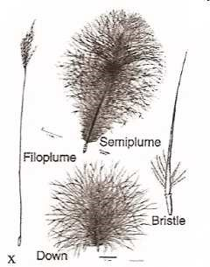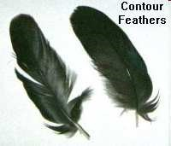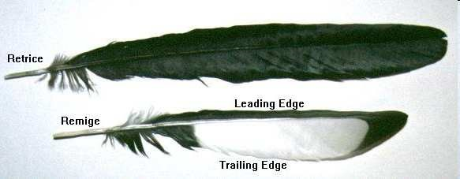 Contour feathers

Coverts

Down

Semiplumes

## 

How a Feather Grows Crested Argus Pheasant

# 